Project Design Phase-II
Data Flow Diagram & User Stories
Date | 06 July 2026
Team ID
Project Name | Online Book Store Management System
Maximum Marks | 4 Marks

Data Flow Diagrams
A Data Flow Diagram (DFD) is a traditional visual representation of the information flows within a system. It shows how data enters and leaves the system, what changes the information, and where data is stored. Below are the Level-0 (Context) and Level-1 DFDs for the Online Book Store Management System.
Level-0 DFD (Context Diagram)
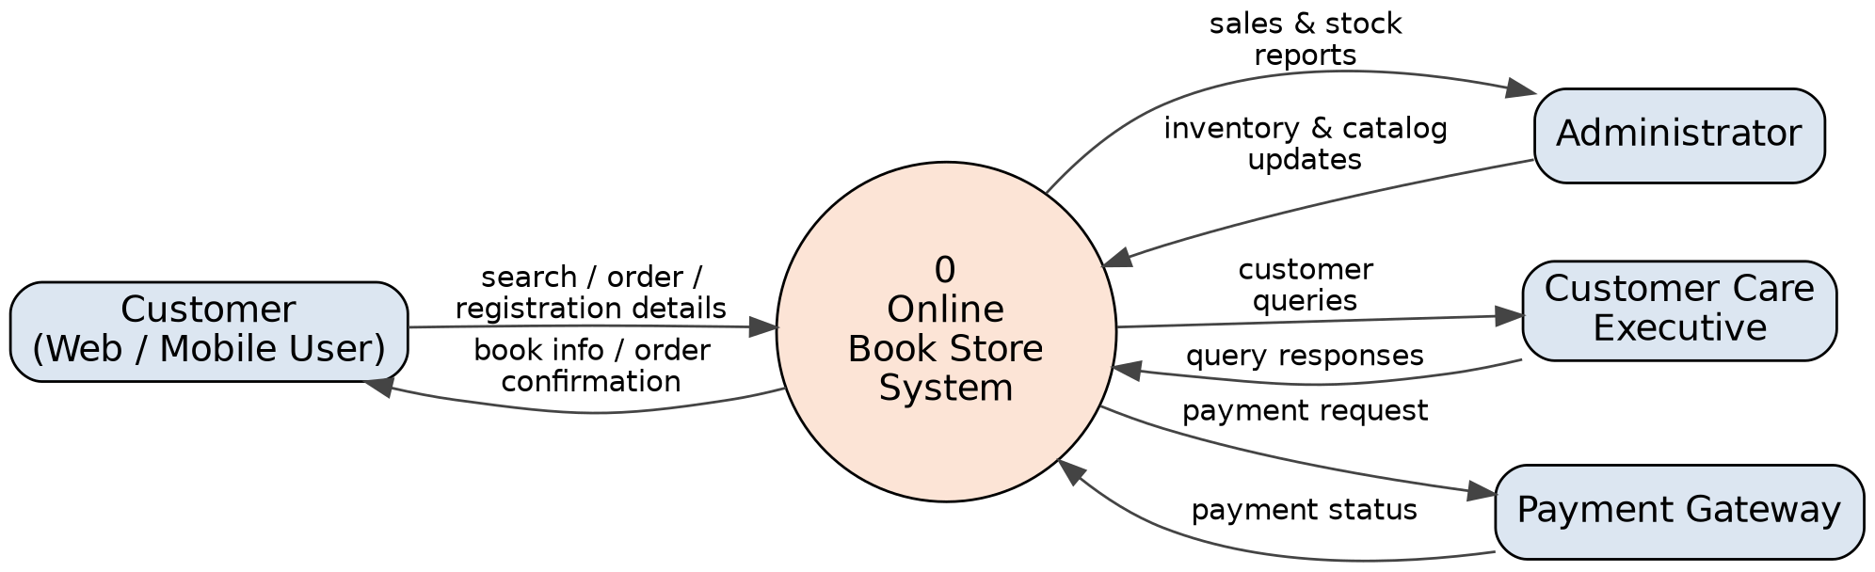
Fig 1: Level-0 Context Diagram – Online Book Store System
Level-1 DFD
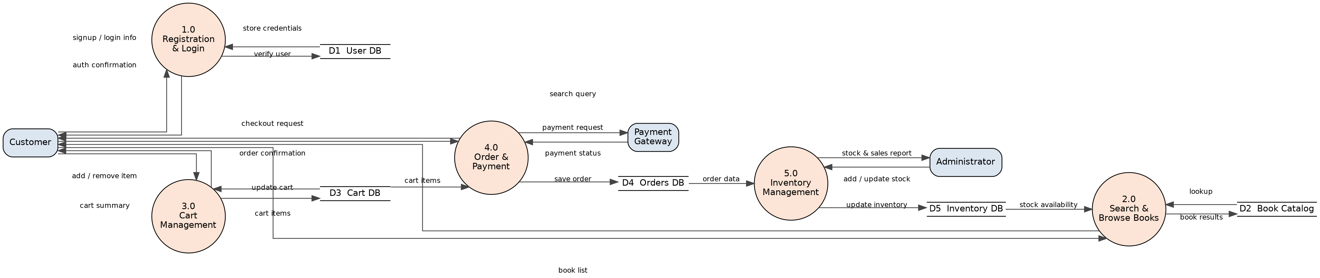
Fig 2: Level-1 DFD – Online Book Store System

User Stories
The table below lists the user stories for the Online Book Store Management System, grouped by user type and functional requirement (epic).
User Type | Functional Requirement (Epic) | User Story Number | User Story / Task | Acceptance Criteria | Priority | Release
Customer (Web & Mobile User) | Registration | USN-1 | As a user, I can register for the application by entering my name, email, password, and confirming my password. | I can access my account / dashboard after successful registration. | High | Sprint-1
Customer (Web & Mobile User) | Registration |  |  | USN-2 | As a user, I will receive a confirmation email once I have registered for the application. | I receive a confirmation email and can click the confirm link. | High | Sprint-1
 |  |  |  | USN-3 | As a user, I can register for the application through Facebook. | I can register and access the dashboard using Facebook login. | Low | Sprint-2
 |  |  |  | USN-4 | As a user, I can register for the application through Gmail. | I can register and access the dashboard using Gmail login. | Medium | Sprint-1
Customer (Web & Mobile User) | Registration | Login | USN-5 | As a user, I can log into the application by entering my email and password. | I am redirected to my dashboard on successful login. | High | Sprint-1
Customer (Web & Mobile User) | Registration | Login |  | USN-6 | As a user, I can log into the application using my Google or Facebook account. | I am logged in and redirected to my dashboard. | Medium | Sprint-2
Customer (Web & Mobile User) | Registration | Search & Browse Books | USN-7 | As a user, I can search for books by title, author, or genre. | Matching books are displayed with cover, price, and availability. | High | Sprint-1
Customer (Web & Mobile User) | Registration | Search & Browse Books |  | USN-8 | As a user, I can filter and sort search results by price, rating, or new arrivals. | The book list updates according to the filter/sort selected. | Medium | Sprint-2
Customer (Web & Mobile User) | Registration | Shopping Cart | USN-9 | As a user, I can add a book to my shopping cart. | The cart icon updates with the correct item count. | High | Sprint-2
Customer (Web & Mobile User) | Registration | Shopping Cart |  | USN-10 | As a user, I can update the quantity of, or remove, items in my cart. | The cart total updates correctly after any change. | High | Sprint-2
Customer (Web & Mobile User) | Registration | Checkout & Payment | USN-11 | As a user, I can check out by providing a shipping address. | I can proceed to payment only after a valid address is entered. | High | Sprint-2
Customer (Web & Mobile User) | Registration | Checkout & Payment |  | USN-12 | As a user, I can pay for my order using a credit/debit card, UPI, or a digital wallet. | Payment is confirmed and an order is created only on success. | High | Sprint-3
 |  |  |  | USN-13 | As a user, I can apply a discount coupon code at checkout. | The order total is recalculated when a valid coupon is applied. | Low | Sprint-3
Customer (Web & Mobile User) | Registration | Order Tracking | USN-14 | As a user, I can view the current status of my order (placed, shipped, delivered). | The order status shown matches the latest status in the system. | Medium | Sprint-3
Customer (Web & Mobile User) | Registration | Order Tracking |  | USN-15 | As a user, I can view my past order history. | All previous orders are listed with date, items, and amount. | Medium | Sprint-3
Customer (Web & Mobile User) | Registration | Reviews & Ratings | USN-16 | As a user, I can rate and write a review for a book I have purchased. | My review appears on the book's page after submission. | Low | Sprint-4
Customer Care Executive | Customer Support | USN-17 | As a customer care executive, I can view a list of open customer queries/tickets. | All open tickets are listed with customer and order details. | High | Sprint-3
Customer Care Executive | Customer Support |  |  | USN-18 | As a customer care executive, I can respond to a customer's query. | The customer receives my reply and the ticket status updates. | High | Sprint-3
 |  |  |  | USN-19 | As a customer care executive, I can process a refund or return request. | Refund status updates and the customer is notified. | Medium | Sprint-4
Administrator | Inventory Management | USN-20 | As an administrator, I can add a new book to the catalog with details, price, and stock count. | The new book appears in search results once saved. | High | Sprint-2
Administrator | Inventory Management |  |  | USN-21 | As an administrator, I can update the price or stock quantity of an existing book. | The updated details reflect immediately on the storefront. | High | Sprint-2
 |  |  |  | USN-22 | As an administrator, I can remove an out-of-print book from the catalog. | The removed book no longer appears in search or listings. | Low | Sprint-3
Administrator | Inventory Management | Order Management | USN-23 | As an administrator, I can view all customer orders. | All orders are listed with customer, items, and status. | High | Sprint-3
Administrator | Inventory Management | Order Management |  | USN-24 | As an administrator, I can update the shipping status of an order. | The customer sees the updated status on their order page. | Medium | Sprint-3
Administrator | Inventory Management | Reports | USN-25 | As an administrator, I can generate a sales report for a given date range. | The report shows total sales, orders, and best-selling books. | Medium | Sprint-4
Administrator | Inventory Management | User Management | USN-26 | As an administrator, I can view and deactivate a customer account. | A deactivated account can no longer log in. | Low | Sprint-4

